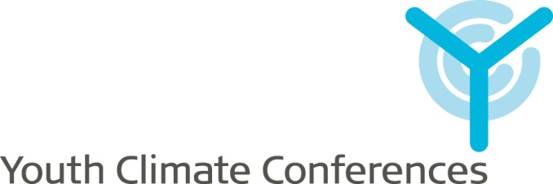

Guidelines
for organising a
YCC Workshop



Youth Climate Conferences (YCC) is organised by the Danish Youth Association of Science (UNF) in collaboration with the International Movement for Leisure Activities in Science & Technology (MILSET).

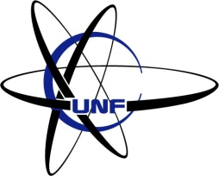

www.ycc2009.org
report@ycc2009.org
March 2009

Introduction
This document explains in detail how to prepare and conduct a YCC Workshop.

Observations

”The poles are melting and the sea levels are rising.”

“Entire crops are destroyed. Animal and plant species face extinction.”

“In Greece, we experience longer summers and winters and they are gradually getting more extreme. This year we had snow! I can’t remember that it happened before…”
What is YCC?
The non-governmental, non-profit and politically independent youth organisations UNF and MILSET are organising the Youth Climate Conferences (YCC); the first world event dedicated to visualize the views and the concerns of youth regarding climate topics by regrouping the voices of youngsters from every part of the globe to state a global opinions and actively enter the debate on their future living conditions. It is our intention to encourage youngsters from all around the world to participate in the climate debate. We are confident that the open-mindedness of young people combined with a scientific approach yields important contributions.

Our goals
Causes

“I think the biggest cause is our habits. We are using and producing far more than we need.”

“Pollution! We consume more and more energy on our planet. And we are not doing it very efficiently…”

“There are more demands made on natural water resources.”

“The world population is growing”

- Set a space where we, the youngsters, can express our concern on climate

- Be engaged in the climate debate that concerns our future and discover our own personal responsibilities

- Express our climate related concerns through various activities

- Present the final result through a statement at the official UN Climate Congress in Copenhagen, scheduled for December 2009

Actions

”We need to change our way of living and begin to care about nature. Every one of us!”

“We need proper education on how to be sustainable and how to change our habits.”

“Support the research and development on new technologies which are more energy efficient and less consuming.”

Through the worldwide network of MILSET, we create a space for youngsters to discuss and present their ideas and suggestions about environmental and climate related topics.

Our primary goals will be reached through four types of activities from August 2008 till September 2009 following a common 3 steps methodology: “Observations, Causes and Actions”.

Types of activities

- A programme of international and national workshops

- Various activities on the website and a forum where you can share your ideas and thoughts

- An informational campaign with youngsters as the target group

How to be a good moderator?

- Don’t make the talk, moderate it. The youngsters are the ones to do it
Tips
”If you have a large group, split it for the brainstorming and discussions”

“If you have a limited time, choose the 5-10 most important observations to discuss the causes and actions”

“Discuss the causes and the actions at the same time; it might be difficult to separate them.”

“Invite the participants to prepare the workshop”

- Keep a good overview on the discussion, what has been said and at which point you currently are

- Develop the report during the discussions

- Work always concerning about your time limitations

- Use moderating or reporting tools like mind maps

- Get the support of the youngsters in your tasks
How to make a workshop in 4 steps?

- Gather a group of youngsters
- Brainstorm on observations on climate related topics
- Define, for each of the observations, the cause(s) and possible action(s)
- Complete and send the report through the online reporting form or to report@ycc2009.org

We invite you to take a look at the tips & tricks section at our online forum for organisers which can be found on www.ycc2009.org, where you can find ideas on how to organise the work.

We also encourage you to e-mail us with further ideas and inform us about your experiences on what worked well at your workshops!

How to present the results?

After your workshop, we would like you to forward us the output through the online form on our website, or by filling out the reporting form and e-mail it to report@ycc2009.org. We need you to:

- Complete the reporting form annexed
- Take some pictures and videos of the activity
- Gather all source materials you think are interesting (mind maps, post-its, etc.)
- If possible, collect information on participants (name, age, nationality, email, level of education)

We accept contributions until the 1st of September 2009!

About the organisers

UNF
The Danish Youth Association of Science (UNF) is a Danish non-profit politically independent organisation of youth with an interest in science. The purpose of UNF is to promote science to youth and give already interested youngsters an opportunity to get an insight into today's science which the school usually is unable to give. The level of difficulty is usually such that everybody who has passed at least the first year of high school (app. 15 years of age) will be able to follow the events with a reasonable understanding and outcome.
We try to promote science in several ways, the main one being lectures and field trips by volunteers from the elite of all fields of science in Denmark. All administration and arranging of lectures and field trips is done by volunteers, usually students, who like to share their spare time with colleagues to promote their common interest.
Every summer since 2002 we have been organising summer camps for high school students in different fields of science, e.g. Biotechnology, Nanotechnology, Mathematics and Game Development. Our Science Camps take place on universities in Denmark during the summer holidays.

More information at: www.unf.dk

MILSET
The International Movement for Leisure Activities in Science & Technology (MILSET) is a non-governmental, non-profit and politically independent youth organisation, which aims at developing scientific culture among young people through the organisation of science-and-technology programs, including Science Fairs, youth congresses, science camps, science contests and experimental activities of high quality as well as training programs and knowledge transfers between member and partner organisations.
Created in 1987, on the occasion of an International Science Fair for Young Researchers held in Québec; MILSET has been presenting a constant and impressive growth regrouping nowadays over 130 organisations from 90 countries dealing with science & technology non-formal and/or extra-curricular education and regrouped in five regional platforms: MILSET Africa, MILSET Amlat (Latin America), MILSET Europe, MILSET Noram (North America) and MILSET Asia.

More information at: www.milset.org

Practical info

Time period

The activities are to be held until 1st September 2009

Website

www.ycc2009.org

Coordinating committee

Youth Climate Conferences
info@ycc2009.org

Project Manager

Danny K. Malkowski
danny.malkowski@ycc2009.org

Coordinator of International Affairs

Antoine van Ruymbeke
antoine.van.ruymbeke@ycc2009.org

YCC reporting form

Please report us, if possible, in English; French, Spanish and Arabic are also accepted. The documents to be in one of the following format: .pdf, .doc, .docx, .txt, .odt.

Information

Name of the activity
Organiser(s)
Location
Level | Regional National International
Dates | From |  | To
Participants | 6-12 |  | 12-18 |  | 18-30 |  | Total
Gender | Male |  | Female
Participating countries
Contact person
Contact email
Description of the activity
Comments

Results

Observations | Causes | Actions
Ex: We have not received results from a country | Ex: There is no workshop in that country | Ex: Organise a workshop!

Once you have completed all forms please submit it to report@ycc2009.org together with pictures and other relevant material from your workshop!

